Fusion 2015 Template and Typing Instructions for Authors Using MS Word

Author_1_firstname Author1_lastname  R&D Department  Huge Corporation  Gigantica, U.S.A.  firstname.lastnameauthor1@huge.com | Author_2_firstname Author2_lastname  Some Good Department  Famous University  Prestige, Canada  firstname.lastnameauthor2@famous.ca

Abstract - Type the abstract (100 to 150 words) using italicized bold font with point size 10. The abstract is an essential part of the paper. Use short, direct, and complete sentences. It should be as brief as possible and concise. It should be complete, self-explanatory, and not require reference to the paper itself. The abstract should be informative giving the scope and emphasize the main conclusions, results, or significance of the work described. Do not use the first person; do not include mathematical expressions; do not refer to the reference, and try to avoid acronyms.

Keywords: Tracking, data association, Kalman filtering, estimation.

Introduction
These are instructions for authors for The 18th International Conference on Information Fusion (FUSION 2015) to be held at the Grand Hyatt Washington, D.C., from July 6-8, 2015. This document has been prepared using the required format. The electronic copy of this document can be found in:
http://fusion2015.org/submissions/
The paper is to be written in two-column format and be right and left justified. The column width should be 83 mm (3.3 inches). The gap between the two columns should be 4 mm (0.15 inches).

Instructions for authors
Adobe PDF version of draft papers intended for regular or special sessions must be submitted to the EDAS site (https://edas.info/N19499) by 1 March 2015. Authors will be notified by 1 May 2015. The PDF version of final papers must be checked by the IEEE PDF eXpress before submission to the web site no later than 1 June 2015. A properly signed copyright form (downloadable from the web site of the conference) must be uploaded onto EDAS. A paper submitted without its copyright form will be withdrawn from the program and will not be published in the proceedings on CD-rom. Please follow the detailed submission instructions available on the conference web site.

Formatting instructions
MS Word Authors: please try to use the paragraph styles contained in this document: Title, Heading 1, Heading 2, Abstract, Keywords, Body Text, Equation, Reference, Figure, and Caption.

Length
Paper length should start with a minimum of 6 pages and is limited to a maximum of 8 pages. Do not number your pages.

Title
Type the title approximately 3.5 centimeters below the top border of the letter size paper sheet and use 20 point type font size. Center the title (horizontally) on the page. Leave approximately 1 cm (0.4 inches) between the title and the name and address of yourself (and of your co-authors, if any). Type name(s), address(es) and email in 11 point and center them (horizontally) on the page.

Spacing
Each section (or subsection) should be separated from the previous text by 6 points.

Section and subsection headings
Number section and subsection headings consecutively in Arabic numbers and type them in bold. Use point size 14 for section headings and 12 for subsection headings. Avoid using too many capital letters. Keep section and subsection headings always flushed left. If any further subdivision of a subsection is needed the titles should be 12 point.

Main text
Use 2 centimeters (0.8 inches) for the left and right margins. Use Times New Roman and font size 10 point for text (character size).
Start a new paragraph by indenting it from the left margin (and not by inserting a blank line), except under a section or subsection heading. Typing area should not exceed 10 x 6.7 inches (25 x 17 centimeters). The text should be prepared with a double column format and single line spacing.

Tables
All tables must be numbered consecutively (in Arabic numbers). Table headings should be placed above the table. Place tables as close as possible to where they are mentioned in the main text.

Figures
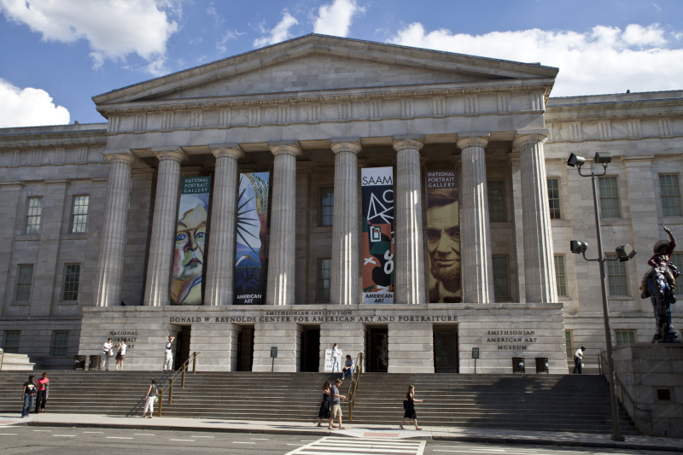
Figure 1. The venue of the Fusion 2015 gala diner.
All illustrations should be original drawings or photographic prints of originals. Photographs should be glossy prints. Photocopies are often not good enough and should be avoided. All illustrations must be numbered consecutively (i.e., not section-wise), using Arabic numbers. Figure captions must be centered beneath the figure. If possible, do not assemble figures at the back of your article, but place them as close as possible to where they are mentioned in the main text. No part of a figure should go beyond the typing area.
According to MS, the correct way to enter a figure and keep the caption associated with it is to insert a text box first and then insert a figure into the text box. To add a caption, click on the figure and select caption. This will place a caption below the figure but inside the text box. You can then move the text box around and the caption will stay with the figure. See, for example, Figure 1 above. Also note that the cross-reference in the previous line to figure 1.

Mathematical formulas
Mathematical formulas should be roughly centered and have to be numbered as formula (1). Add spaces between the formula and the number to center the equation.

$F=m\frac{d\overset{˙}{x}}{\text{dt}}$ (1)

References
References to the literature should be mentioned in the main text by an Arabic number in square brackets []. List these [] (in numerical order) at the very end of your paper (under the heading References). Start each reference on a new line with its number in square brackets []. This template uses endnotes (under insert/footnotes in MS Word) for automatic entry of references and it uses cross references for repeated reference to a previously used reference such as [Error: Reference source not found] which refers again to reference one. Be sure to select all (ctrl-a) and “update field” to update all references before final submission.

Fine tuning
Make sure acronyms are properly defined the first time they appear in the text. Pay attention in reviewing not only the source file (MS Word or LaTeX) but the PDF file as well for your draft and final versions. Make sure that pages do not end with a section or subsection heading.

Final version
After proofreading your paper, a PDF version must be uploaded on the EDAS page (https://edas.info/N19499). Conformity with IEEE PDF eXpress must be checked before the upload. Do not send hard copies, do not use other file formats – they will not be accepted.
Any submission failing to follow the above guidelines will be withdrawn from the conference program and proceedings (CD-ROM).

Sources of LaTeX information
For those who decide to use LaTeX typesetting language instead of MS Word, a separate example document can be found on the FUSION 2015 conference website at http://fusion2015.org/submissions/.

Conclusion
We tried to keep these formatting instructions as simple as possible. A well-crafted paper is easier to read and there is more to this than only formatting. We encourage authors to pay careful attention to the quality of their English. We hope to see you next July in Washington for the 18th International Conference on Information Fusion.

References

- Firstname Author1_lastname et al., “A truly outstanding paper,” Superb Conference 2006, Optional sub-conference topic, editors if known, Conf. location and date, Proc. 1234, pp. xxx-yyy.
- Firstname Author2_lastname, and A. Friend, “My favorite journal paper,” JAIF, vol. 1, no. 1, pp. xxx-yyy, July 2006.
- Nobel Laureate, His book, Publisher, Location, Year.

